Data Analytics
Student Habits Performance

Politician text analysis
Assoumany Yeningna Orlane Kone
Nunekpeku Kimberly Elorm
Contents:
PART ONE: STUDENT HABIT PERFORMANCE
- Introduction
- Data Preparation
- Exploratory Data Analysis
- Statistical Analysis
- Predictive Modeling
- Clustering
- Recommendations
- Limitations and Future Work
- Conclusion
An Appendix: Code and Additional Outputs

PART TWO: POLITICIAN TEXT ANALYSIS(HENRY KONAN BEDIE)
- Introduction
- Data Preparation
- Cleaning the text
- Tokenization
- Stopwords Identification and removal
- Stemming and lemmatization
- word frequencies and TF-IDF
- Sentiment analysis
- Conclusion
An Appendix: Code and Additional Outputs

1. Introduction

Understanding what leads academic performance is a complicated challenge in education. This report looks at data from 1000 students to see the impact of everyday habit (like sleep, screen usage, what they eat, …) on their exam scores.

The analysis will be structure like this:
      - Data preparation and feature engineering to transform raw variables into analytical inputs.
      - Exploratory data analysis to surface distributions, correlations, and initial patterns.
      - Statistical test
      - Linear regression modelling to see the prediction power ● K-means clustering to identify student behavior profiles.
      - Targeted recommendations for educations and institutions based on the findings

2. Data Overview and Preparation
2.1 Dataset Description

The dataset “Student habits performance” is about habits that students have every day and the exam results they obtains. We have for columns: student id, age, gender, study hours per day, social media hours, Netflix hours, part time job, attendance percentage, sleep hours, diet quality, exercise frequency, parental education level, internet quality, mental health rating, extracurricular participation and exam score.

In this dataset we have 1000 rows and 16 columns, here the first five rows of the dataset:

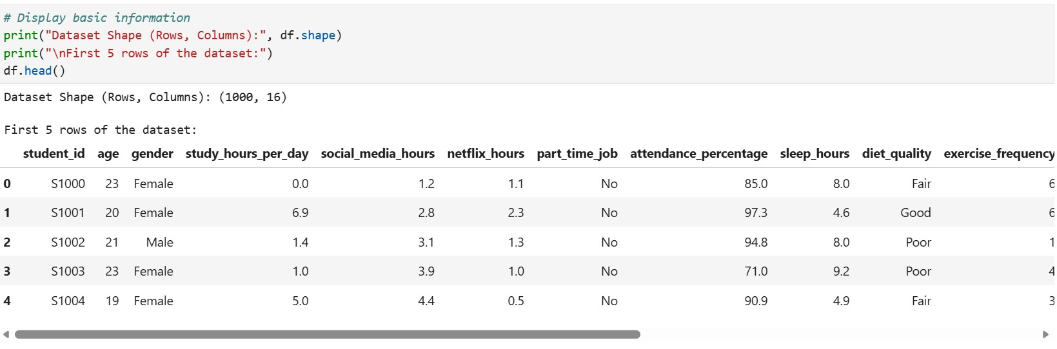
First Five rows of the dataset
The five last rows of the dataset:
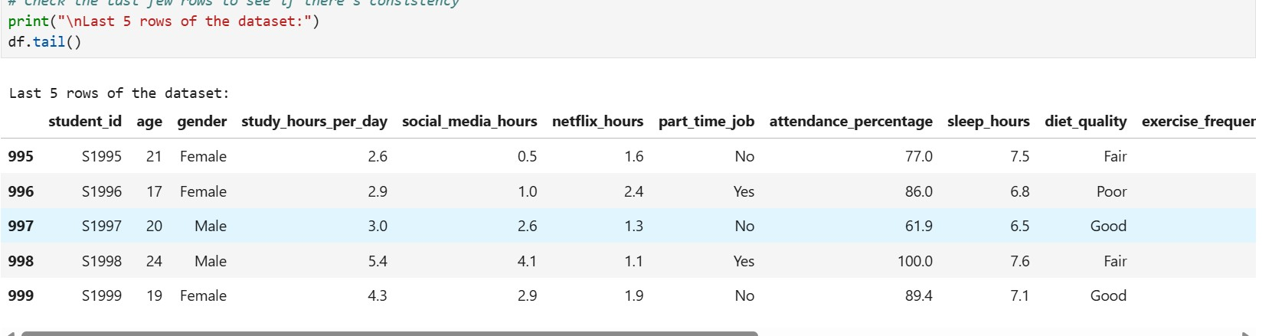
Last five rows of the dataset

The dataset information:

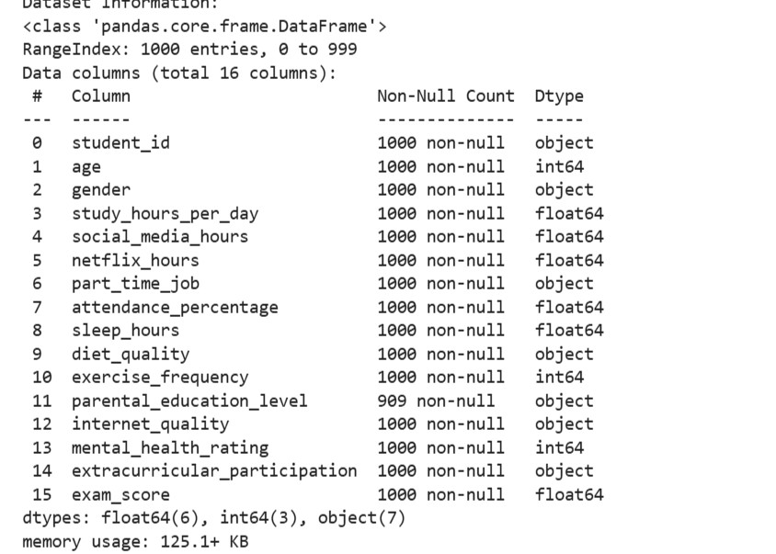
Dataset scheme and non-null counts

The data types of each column:
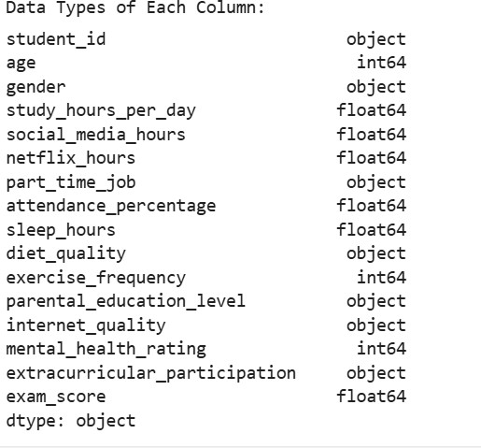
Column data types

Descriptive Statistics for numerical columns:

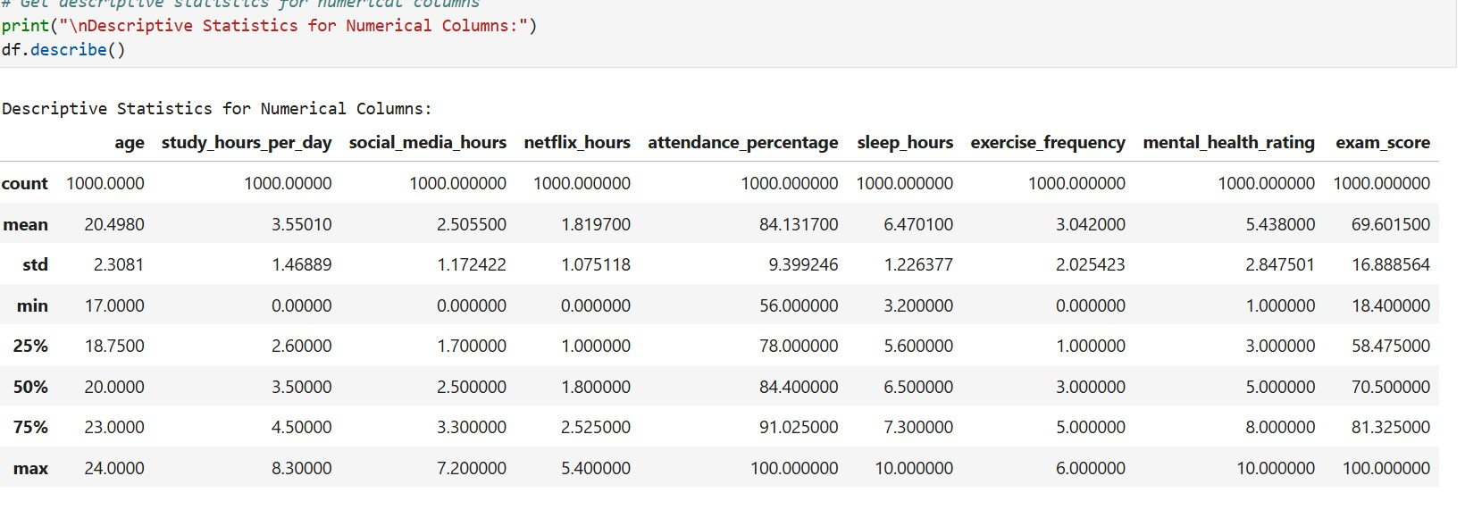
Descriptive statistics summary
2.2 Data Cleaning
We are starting by displaying Missing Values in Each Column:

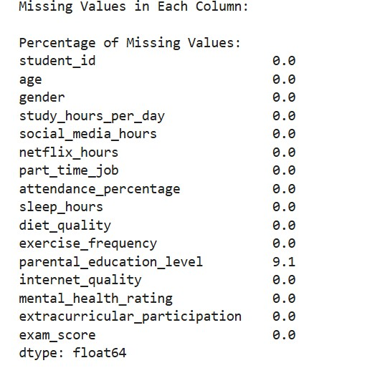
Missing value counts per column

After we handle missing values for parental education level:
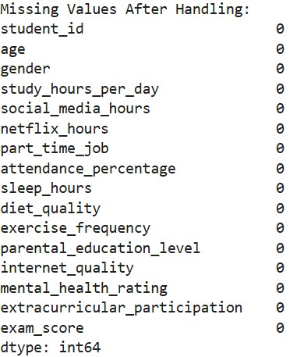
Missing values after handling parental education level

For this dataset we don’t have duplicated rows and unique values in categorical columns are:
student_id unique values
First 10: ['S1000' 'S1001' 'S1002' 'S1003' 'S1004' 'S1005' 'S1006' 'S1007' 'S1008' 'S1009']

gender unique values
['Female' 'Male' 'Other']

part_time_job unique values
['No' 'Yes']

diet_quality unique values
['Fair' 'Good' 'Poor']

parental_education_level unique values
['Master' 'High School' 'Bachelor']

internet_quality unique values
['Average' 'Poor' 'Good']

extracurricular_participation unique values ['Yes' 'No']
For the rest of the work, we decide to drop student id column because it not necessary.

2.3 Feature Engineering
We start the features engineering part by encoded binary columns. We obtain, part_time_job (where unique values yes and no of the columns has_jod become respectively 1 and 0), and extracuricular_participation (where unique values True and False become also 1 and 0). Then, we encode ordinal columns, gender become gender_encoded with male= 0, female= 1, and other= 2, diet_quality = diet_encoded with poor=0, fair=1, good= 2, internet_quality transform to internet_level where poor=0, average=1, good=2, to end parental_eduaction_level become parent_edu_level with none= 0, high school= 1, bachelor= 2, master= 3, phd=4. We move to the part of transforming numerical columns: we group age, sleep_hours and attendance_percentage into three parts each. We make interaction between some features: total_distraction_hours= social_media_hours + Netflix_hours, study_efficiency = study_hours_per day/ sleep_hour, productive_hours = study_hours_per_day * attendance_percentage, wellness_score= diet_encoded + exercise_frequency + sleep_hours (each normalized to [0,1]). We finally drop columns that are not important for the rest of our work like age, social_media_hours, diet_encoded, etc….

- Exploratory Data Analysis

Before modelling, key distributions and relationship were examined visually and numerically.

  - Univariate Distributions
Exam score | Mean 69.6 ,SD 16.9, Min 18.4, Max 100
Study hours per day | Mean 3.55, SD 1.47, Min 0, Max 8.3
Sleep hours | Mean 6.47, SD 1.23, Min 3.2, Max 10
Mental health rating | Mean 5.44, SD 2.85, Min 1, Max 10
Social media hours | Mean 2.51, SD 1.17, Min 0, Max 7.2
Netflix hours | Mean 1.82, SD 1.08, Min 0, Max 5.4
Attendance percentage | Mean 84.1%, SD 9.4%, Min 56%, Max 100%
Exercise frequency | Mean 3.04, SD 2.03, Min 0, Max 6

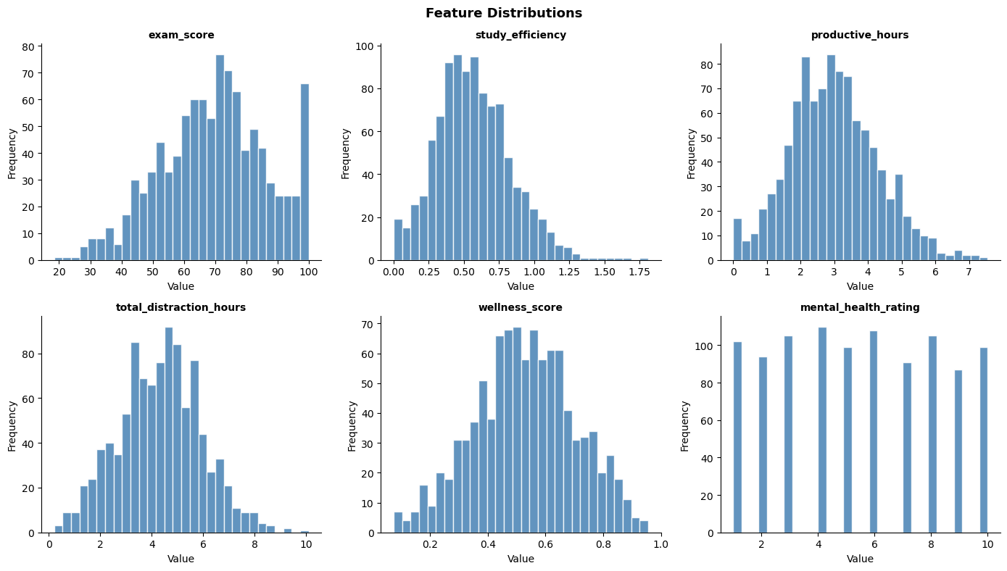

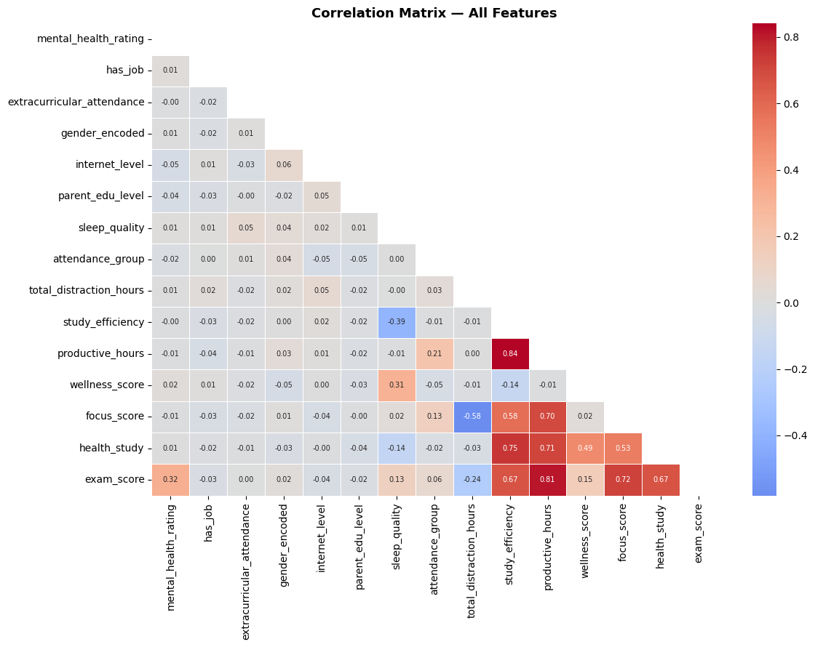
  - Correlation Analysis

Study hours per day | r = +0.83
Mental health rating | r = +0.32
Exercise frequency | r = +0.16
Sleep hours | r = +0.12
Attendance percentage | r = +0.09
Social media | r = -0.17
Netflix hours | r = -0.17

These correlations motivate the feature engineering choices: composite variables such as study_efficiency, productive_hours, and total_distraction_hours amplify the individually weaker signals into stronger predictors.

=== Feature Correlations with exam_score (sorted) ===
productive_hours +0.809 ████████████████████████
focus_score +0.716 █████████████████████
study_efficiency +0.666 ███████████████████
health_study +0.666 ███████████████████
mental_health_rating +0.322 █████████
wellness_score +0.155 ████
sleep_quality +0.127 ███
attendance_group +0.058 █
gender_encoded +0.016
extracurricular_attendance +0.001
parent_edu_level -0.022
has_job -0.027
internet_level -0.036 █
total_distraction_hours -0.238 ███████

- Statistical Analysis

Study time is the most powerful leader of exam performance. It correlation (r=0.83) indicated that 68ù of the variance in exam score can be cause by study hours alone. It represents the strongest features signal in the dataset. Mental health shows a moderate association that means that student wellbeing also contributes to academic outcomes, beyond study effort.
Distractions (social media and Netflix) is negatively correlated with performance.

Metric | value
Sample Size (n) | 1000 students
Mean exam score | 69.6/100
Standard deviation | 16.9
Min score | 18.4
Max score | 100
Interquartile range (IQR) | 58.5-81.3 (range: 22.8pts)
Missing values | 91 (parental education level only)

Variable Significance
    - Study efficiency (study hours/ sleep hours)
    - Productive hours (study hours x attendance)
    - Wellness score (diet+exercise+sleep normalized)
    - Mental health rating
    - Attendance group
    - Sleep quality
    - Total distraction hours
    - Has job, extracurricular attendance, focus score, health study

- Predictive modeling
We starting by transforming categorical column into numerical and we proceed to the regression where features like study efficiency or sleep_quality are regrouped in features_reg. Here we want to predict exam_score according features_reg. we do linear regression where R² =0.8401 and RSME=6. By interpreting these results, we see that our model explains 84% of the variance in the data. That is a good result and it also means our features are genuinely good predictors.
To follows our predictions are off by 6 points out of 100 (Root Mean Square Error). For example, if the student obtains 75, our model might predict anywhere from 69 to 81.
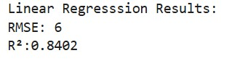
Actual vs Predicted Plot
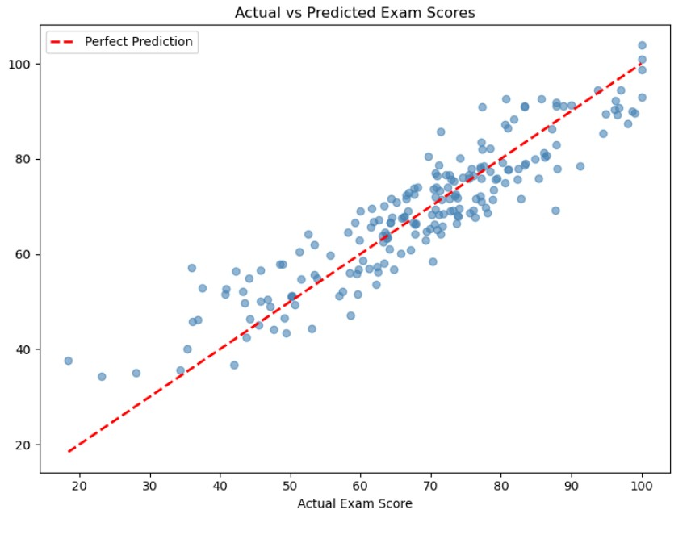
Actual vs Predicted exam scores

This is the Actual Vs Predicted plot and it confirms that the model performs well across the full score range. Prediction are strongest for average students (50-85), with minor underestimation for high scorers and slight overestimation for low scorers.

6. K-means Clustering

In this part start by choosing features,

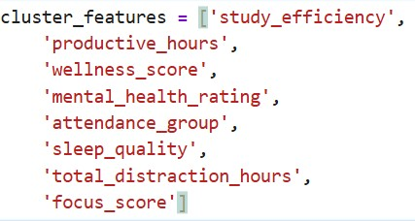

then we do the elbow methods to know how many clusters we will have.
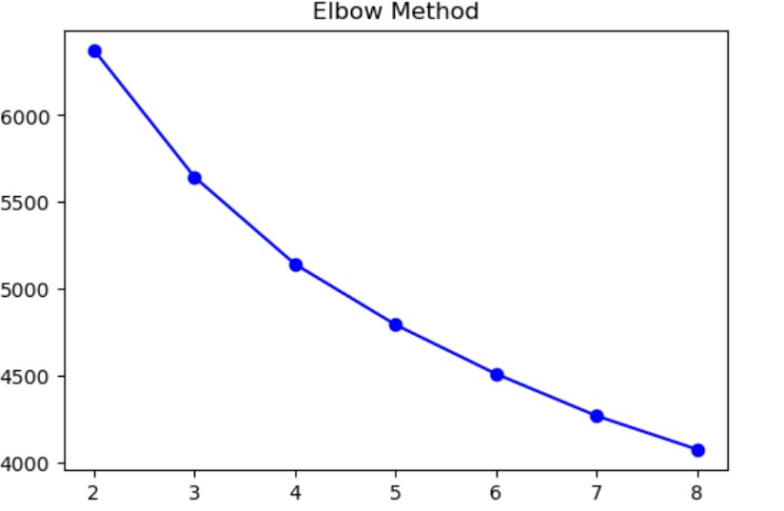

Elbow method: inertia vs number of clusters
In this case we will have 4 clusters. We use our features to make our cluster and it give this result:
We made
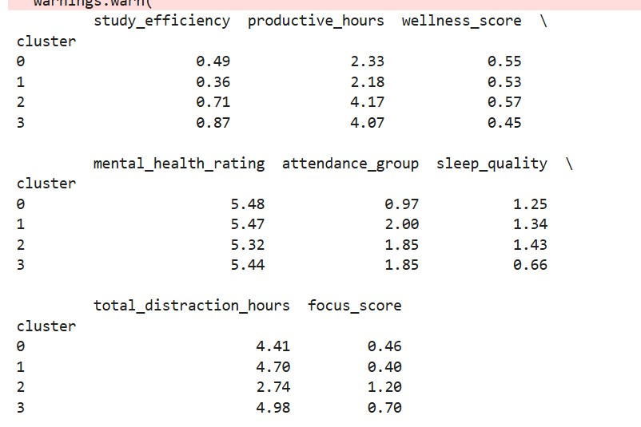

Mean features values per cluster

We made scatters plot to visualize clusters in two cases (exam score per study hours/day and exam score per total distraction hours).
Cluster scatter plots: exam score vs study efficiency(left) and vs total distraction hours (right)

In the first plot (exam score per study hours), we see that cluster 0 (blue) represent struggling students, study hours and exam score are low. Cluster 1 (orange) is average students we can see that study hours and exam score are between low and medium. Cluster 2 (green) and cluster 3 (pink) are the highest students in term of study hours and exam score. We see that study hours and exam score have a strong relationship (more study hours = higher exam score).
The second plot about distraction hours vs exam score show cluster 0 and cluster 1 with the highest distraction hours and then cluster 2 and cluster 3 with less. Here also the plot show that distraction hours have impact on exam score (Cluster with less distraction hours have higher exam score).
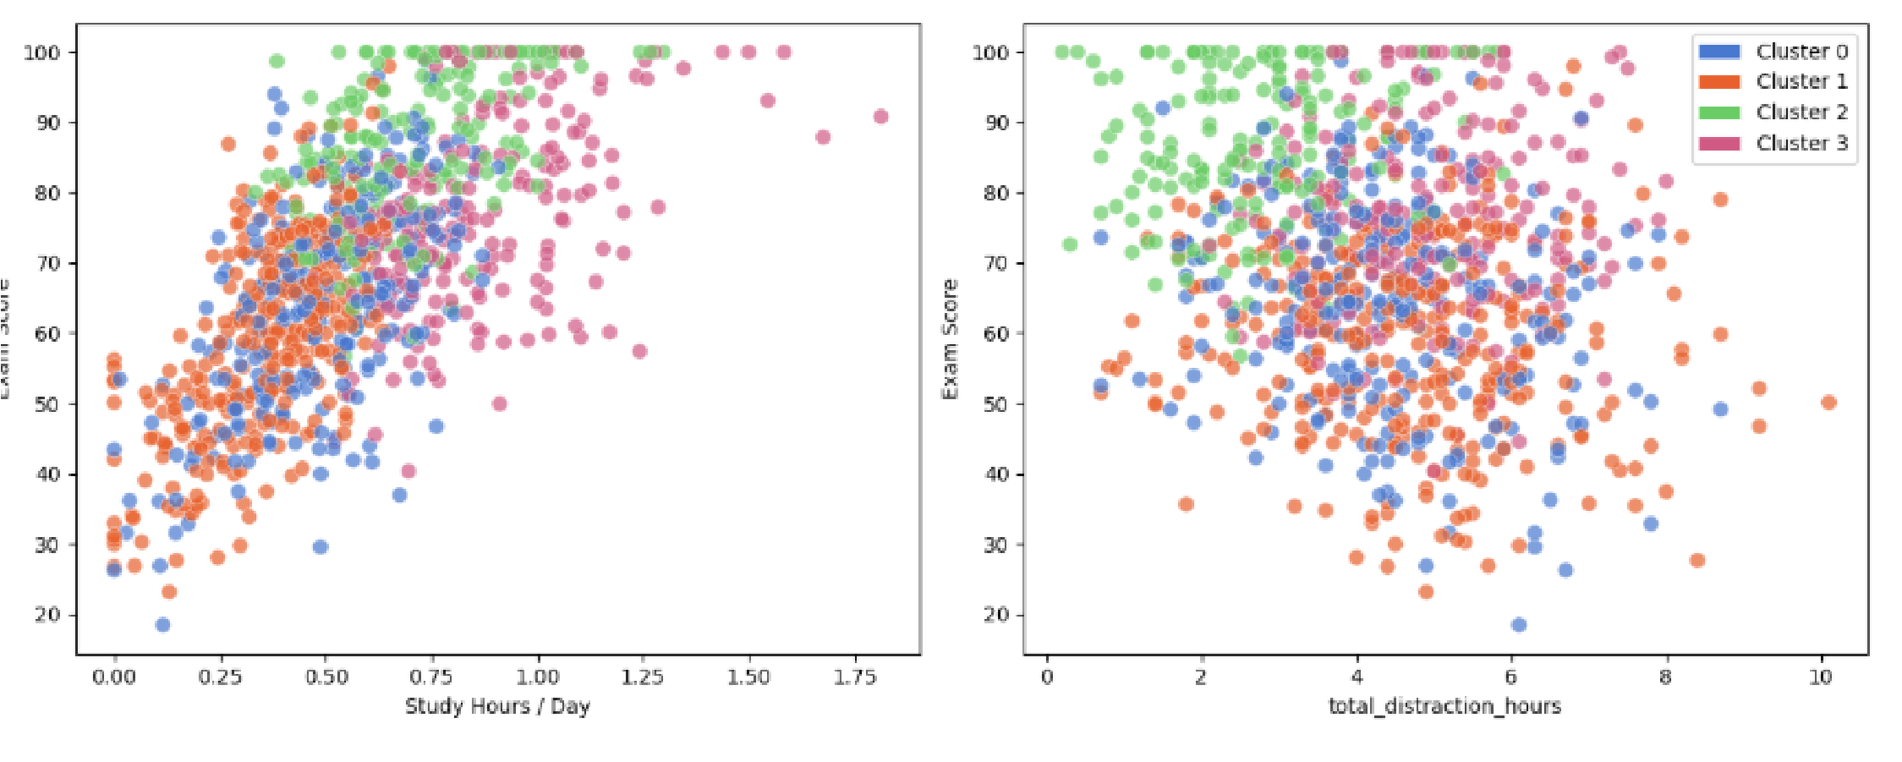
In conclusion, the four clusters represent fours differents students profiles. Cluster 0 are the struggling ones with low study hours and high distraction hours. Cluster 1 are average students with medium habits. Clusters 2 represents high levels students with strong disciples and clusters 3 the excellences ones who achieve high scores regardless of distraction levels, likely driven by superior study efficiency.
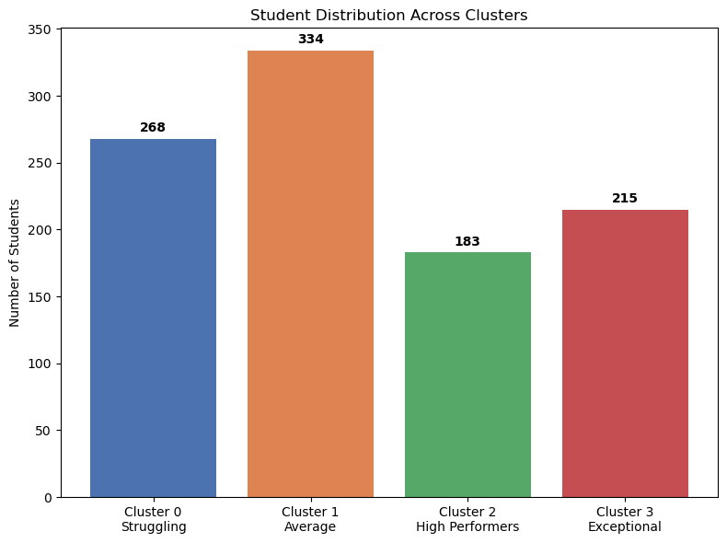

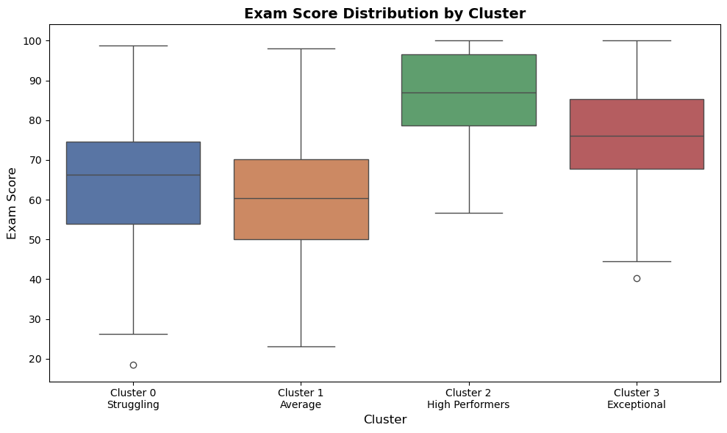
- Recommendations

Based on the statistical, modelling, and clustering findings, the following recommendations are proposed:

  - Priorities Study Habit Development

Study hours represent the strongest predictor for exam performance. Institutions should implement structured study support programs and give quiet study space.

  - Address Mental Health proactively

Mental health rating is the second strongest predictor. Schools must invest in wellness surveys, accessible counselling services.

  - Reduce Screen Based Distraction
Social media and Netflix usage are negatively correlated with exam scores. Awareness campaigns about screen time management and app blocking tools during study periods could help students
  - Promote Sleep and Physical Wellness
Average sleep in the database (6.47h) is below the recommended 8 hours, and sleep quality is independent predictor in the regression model. Institutions should run sleep education campaigns and promote physical activity programs.
  - Tailor intervention by cluster
The clusters provide student segment for differentiated support strategies:
    - Cluster 0: intensive study, mental health support, distraction reduction programs.
    - Cluster1: motivational support, study efficiency workshop, goal setting tools.
    - Cluster 2 and 3: advanced learning opportunities, leadership roles.

- Limitations and Future Work

Limitations

      - Missing parental education: 91 records had missing parental education level.
      - Single exam score: Academic performance is captured by a single exam score which may not represent academic achievement across multiple subjects.
      - No institutional context: Students come from an unspecified institution and country.
Future Work
      - Expanded outcomes variables: Including GPA and course specific grades would provide a richer picture of the academic impact of the student habits.
      - Text and qualitative data: Survey questions about study strategies and personal challenges could complement the quantitative analysis.
- Conclusion

This analysis shows that student habits are powerful predictors of academic performance. Applied to 1000 students, the full analytics pipeline produced the following key findings:

o Study time is the dominant driver o Mental health and wellness matter independently o Screen based distraction has a measurable negative effect o Four student profiles emerge from K-means clustering
In summary, the data shows that academic success isn’t being naturally smart or going to a good school. It actually comes down a lot to the everyday choices you make. Being able to put actual numbers to all of this is really useful because it means support for struggling students can be way more practical and target instead of just advice.

Introduction
This report presents a Natural Language Processing (NLP) analysis of a French text concerning Henri Konan Bédié, one of Côte d’Ivoire’s most prominent political figures and former President. The aim of this study is to examine the linguistic characteristics, dominant themes, and emotional tone of the document using various text analysis techniques, including cleaning, tokenization, stopwords removal, stemming, lemmatization, word frequency, TF-IDF, and sentiment analysis.

Data Preparation
The dataset used for this analysis is a single text file named HKB.txt. The file was successfully loaded using Python with UTF-8 encoding to properly manage French accents and special characters. The document contains approximately 600 words and appears to be a tribute or commemorative speech related to Henri Konan Bédié.

Cleaning the Text
Several cleaning operations were applied to the raw text. Citation markers such as [1] and [2] were removed, unnecessary special characters were filtered out, extra whitespaces were normalized, and the entire text was converted to lowercase.
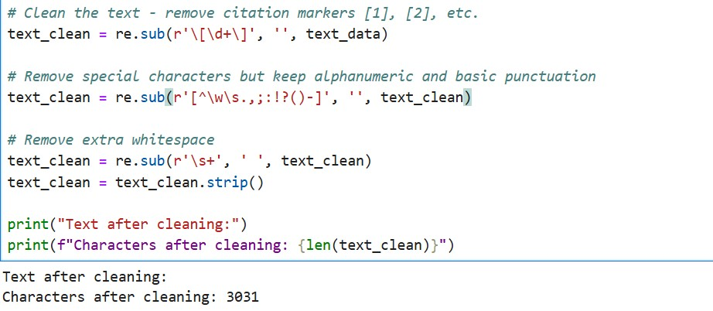
By cleaning the text, we ensure higher accuracy in later stages like tokenization and frequency counting, while preserving the original meaning and structure of the speech.

Tokenization
Tokenization was performed using NLTK’s word_tokenize() function. The text was split into individual words, and only alphanumeric tokens were kept for analysis.
Results:
- Total tokens (including punctuation): 608
- Alphanumeric tokens retained: 544
Interpretation:
This process transformed the continuous text into discrete units that are easier to analyze. The reduction from 608 to 544 tokens shows that punctuation accounted for a reasonable portion of the original text, which is common in well-written political speeches.

Stopwords Identification and Removal
French stopwords were removed using NLTK’s French stopwords list.
Results:
- Words before removal: 544
- Words after removal: 303
- Percentage of words removed: 44.3%
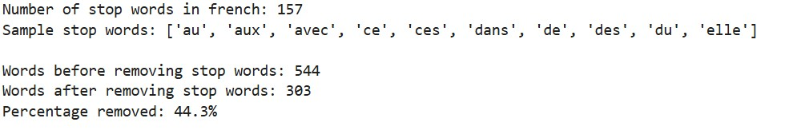
Interpretation:
Stopwords (common words such as “le”, “de”, “et”, “à”, etc.) carry very little meaningful information. Removing them reduced the dataset by nearly half and allowed the analysis to focus on the most significant and content-rich words in Bédié’s text.

Stemming and Lemmatization
Stemming and Lemmatization were applied to reduce words to their root forms.
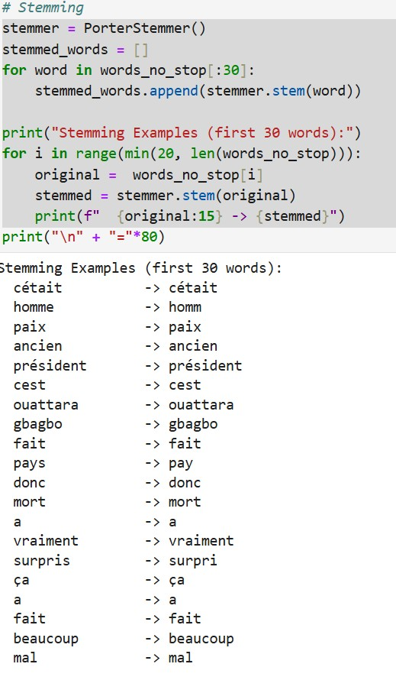
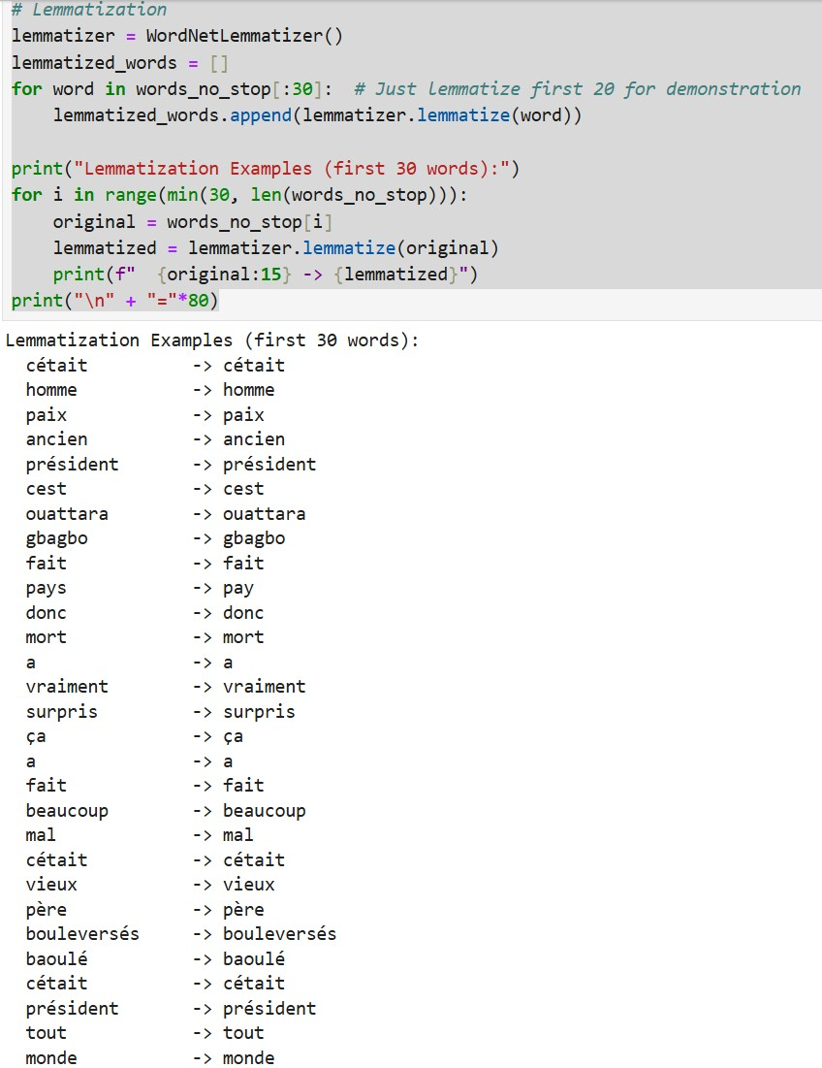
Interpretation:
Both techniques had limited impact because they are primarily designed for English, while the document is in French. Most words, especially proper names (Bédié, Ouattara, Gbagbo) and key terms like “président” and “paix”, remained almost unchanged. Nevertheless, this step helped normalize minor variations and confirmed the central political and commemorative vocabulary present in the speech.

Word Frequencies and TF-IDF
Top 20 Most Frequent Words (after stopword removal)
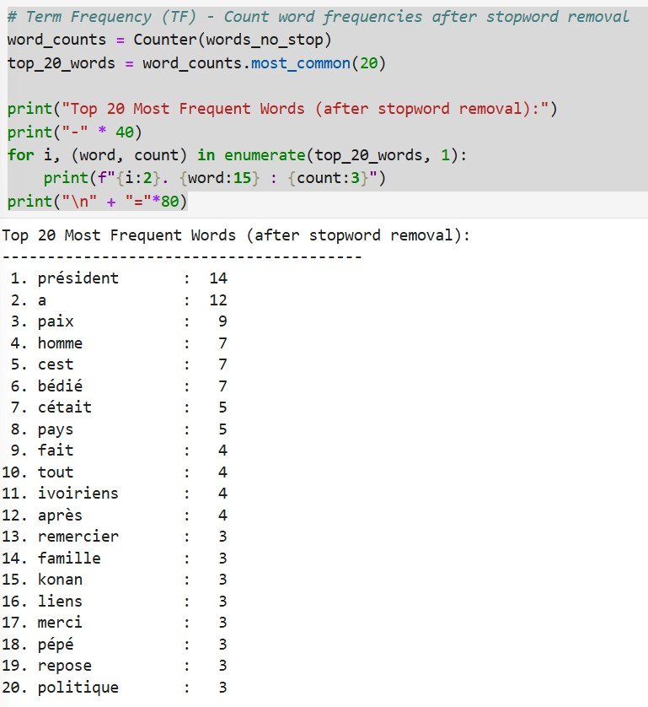
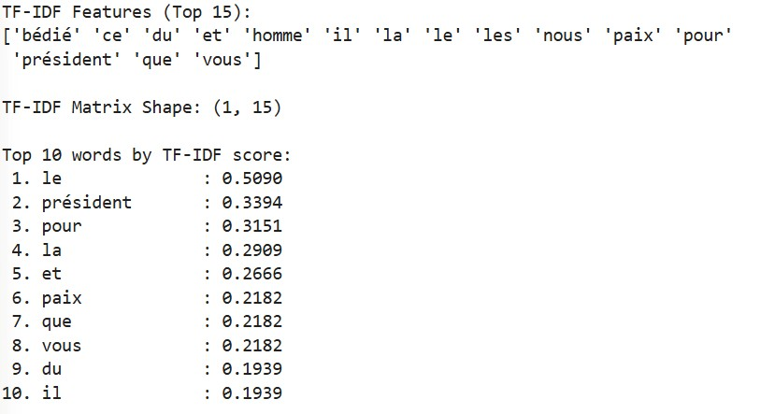
Interpretation:
The frequency analysis strongly indicates that this document is a tribute speech honoring Henri Konan Bédié. The repeated use of “président”, “bédié”, “paix” (peace), “homme” (man), and “pays” (country) clearly highlights the main themes: leadership, peace, respect, and national unity. The TF-IDF results supported these findings, emphasizing the importance of words related to Bédié’s legacy and the call for peace.

Sentiment Analysis
Sentiment analysis was carried out sentence by sentence using the TextBlob library.
Results:
- Average sentiment score: 0.0294 (Slightly positive)
- Positive sentences: 2
- Negative sentences: 0
- Neutral sentences: 32
Interpretation:
The overall sentiment of the text is slightly positive with a very calm and respectful tone. The majority of sentences are neutral, which is typical for a commemorative speech. There are no strongly negative sentences, showing that the speaker focused on dignity, gratitude, and hope rather than criticism or mourning. The most positive sentence emphasizes the challenges and responsibilities facing Bédié’s political supporters today.

Conclusion
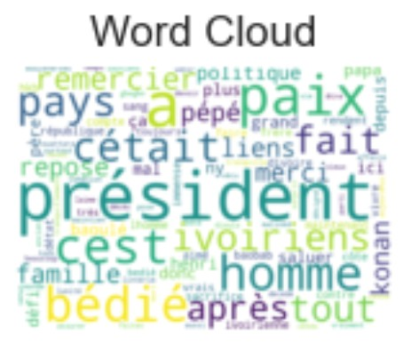
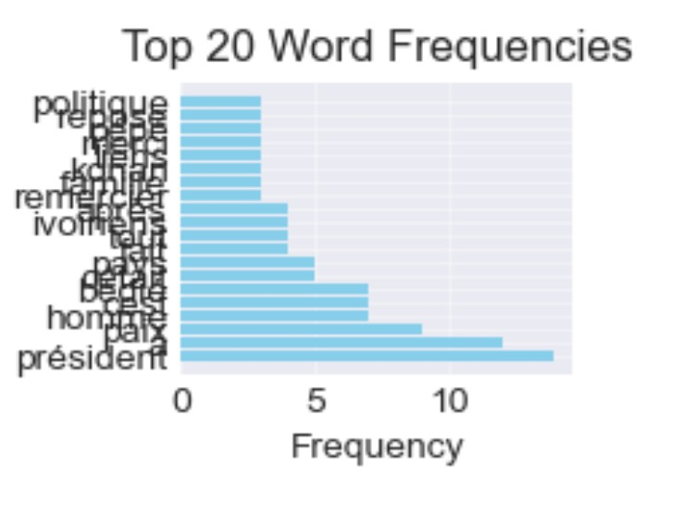
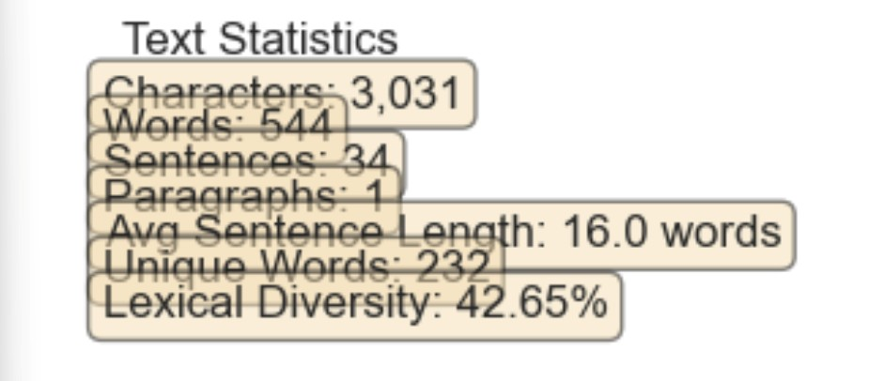
This NLP analysis reveals that the text is a respectful tribute to Henri Konan Bédié. The dominant themes are his role as president, his contribution to peace (“paix”), and his legacy for the Ivorian people (“ivoiriens”). The frequent appearance of words linked to leadership and national unity reflects the speaker’s desire to honor Bédié’s memory while promoting reconciliation.
The slightly positive sentiment score confirms the dignified and constructive tone of the speech. Although some limitations exist — mainly because several NLTK tools are English-oriented and the analysis is based on a single document — the results successfully highlight the core message and emotional tone of the text.

